MACH4METAL

metalworking machinery
Transito 21,
6909 DA BABBERICH
Netherlands
Tel. +31 (0)316 – 247123
Fax. +31 (0)316 - 247956
info@mach4metal.com
www.mach4metal.com

Bank No : 66.52.13.883
IBAN : NL33 INGB 0665 2138 83
BIC : INGBNL2A

DECKEL MAHO DMU 50 M
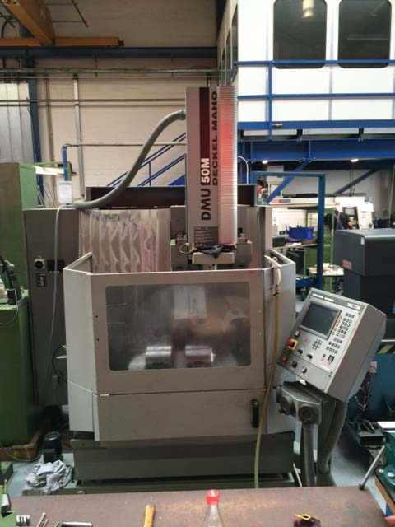
- Make : Deckel Maho
- Type : DMU 50 M
- Mach. No : 1102 5537 654
- Age : 2003

- Capacity / Working area;
- X - Travel : 500
- Y - Travel : 400
- Z - Travel : 400

- Table length : 700
- Table width : 500
- Rotation : 360 Gr.
- Table load : 200 Kg

- Spindle : Sk 40
- Speeds : 20 – 4.500 Rpm
- Power : 9 kW
- Feeding range : 5.000 mm/min
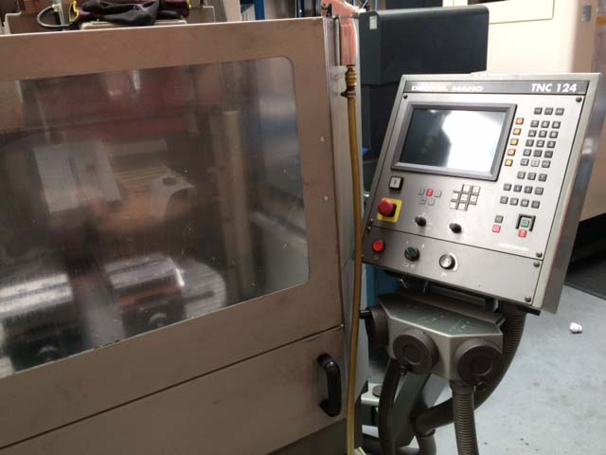
- Rapid traverse : 5.000 mm/min

- HeidenHain TNC 124 with 3 + 2 Axis
- B & C Axis digital on screen

- Dimensions
- Length : 2.610
- Width : 2.700
- Height : 2.500
- Weight : 3.800

Please Note: The above information has been obtained to the best of our ability and belief from, and from the manufacturers where possible. It is given in good faith, but its accuracy can not be guaranteed. Accordingly, it will not form a representation or constitute contractual terms. We advise you to check any vital details!

